Proposal: Employee Engagement & Recognition Platform
Prepared for: The Arc Mercer Prepared by: IoTeye Inc. Date: April 17, 2026 In Response To: Request for Proposal — Employee Engagement & Recognition Platform (February 2026)

Table of Contents
- Executive Summary
- Company Profile
- Technical Approach
- Scope of Work & Solution Design
- Integration Strategy
- Accessibility Statement
- Phased Implementation Plan & Timeline
- Cost Proposal
- Appendices
  - Appendix A: Technology Stack Detail
  - Appendix B: Data Security Summary
  - Appendix C: Support & Maintenance
  - Appendix D: Competitive Feature Matrix & Revision Log

1. Executive Summary
We are pleased to submit this proposal in response to The Arc Mercer's Request for Proposal for an Employee Engagement & Recognition Platform. We understand the critical importance of transitioning from manual recognition processes to a structured, scalable system that fosters a culture of appreciation across your residential and day programs.
Our proposed solution is a custom-built, cloud-hosted SaaS platform leveraging modern, battle-tested technologies — React and TypeScript for the front end, Supabase (PostgreSQL) for the backend and real-time data layer, Python for integrations and business logic services, and AWS for secure, scalable cloud deployment. This technology stack delivers a high-quality, maintainable, and cost-effective platform tailored precisely to The Arc Mercer's unique requirements.
Key Differentiators:
- Custom-Built for Your Workforce: Unlike off-the-shelf platforms, our solution is designed from the ground up for non-technical, frontline staff — large buttons, intuitive icons, minimal text, and mobile-first design.
- Seamless Paycom Integration: A dedicated Python integration service ensures reliable, automated user provisioning and program assignment syncing with your Paycom HRIS.
- Phased Delivery with Early Value: Phase One goes live within 12 weeks of kickoff, delivering nominations, Paycom sync, and manual point support immediately.
- Transparent & Auditable: Every point adjustment is logged with full audit trails, giving leadership complete visibility and control.
- Scalable SaaS Architecture: AWS-hosted infrastructure scales with your organization and ensures 99.9% uptime.

2. Company Profile

About IoTeye Inc.
IoTeye Inc. is a remote software products company headquartered in Basking Ridge, New Jersey. For over 5 years, IoTeye has been building and delivering high-quality software products and tools — with a particular focus on the special care sector. Over 1,000 consumers trust IoTeye's platforms today.
Website:www.ioteyeinc.comContact: mingjye.sheng@ioteyeinc.com

Solutions & Services
IoTeye's portfolio spans multiple domains directly relevant to The Arc Mercer's mission:
Area | Description
Special Care | Purpose-built tools for organizations serving individuals with specialized care needs — IoTeye's core domain and the foundation of our understanding of your workforce.
BrainBook (AI Agents for Special Care) | AI-powered agent platform tailored for special care organizations, demonstrating our capacity to build intelligent, data-driven business systems.
Route Optimization | Intelligent routing solutions — our flagship product — showcasing expertise in real-time data processing and optimization algorithms.
Communication Studio | Communication and engagement tools, directly transferable to employee recognition and notification systems.
Class Attendance & Contact Tracing | Attendance tracking and people-management systems, demonstrating experience with check-in workflows and activity logging similar to the TAC meeting and engagement tracking required in this RFP.

Products
- SpringBoard — IoTeye's flagship multi-agency route management and operations platform. SpringBoard provides a comprehensive admin portal for special care transportation organizations, including route optimization, fleet management (OBD and camera integration), vehicle maintenance tracking, scheduling (cron-based automation), and Twilio-powered SMS/conversational communication. The platform features a multi-tenant architecture supporting multiple agencies (e.g., Arc Mercer, Easter Seals), a React-based admin dashboard, REST APIs for mobile and web clients, and a robust security framework with role-based access control. SpringBoard demonstrates IoTeye's proven ability to build and operate complex, data-driven SaaS platforms for the special care sector.
- BrainBook — An AI-powered platform built with Next.js 14 (React/TypeScript), Supabase authentication, and Tauri for cross-platform desktop deployment. BrainBook features local AI model management and inference, an interactive chat interface with streaming responses, AI-driven note generation, voice I/O (text-to-speech and speech-to-text), an agent system with a standalone agent server, workflow automation integration, and OAuth/SSO authentication. The platform runs as both a web application and a native desktop app, demonstrating IoTeye's expertise in React, TypeScript, Supabase, and modern full-stack architecture — the same technology stack proposed for this project.
- Guardian — A multi-agency, multi-department notification, communication, and authentication system. Guardian provides SMS messaging (via Twilio), mobile push notifications (via Expo), reply tracking, confirmation workflows, and location-aware alerts — all organized by agency and department. The system includes a server backend (Node.js/Docker/Supabase) and a cross-platform mobile app (React Native/Expo) published to both iOS and Android app stores. Guardian's multi-tenant architecture, real-time notification capabilities, and authentication services directly parallel the engagement, notification, and authentication features required for this project.
- BrainClaw (AI Agent Gateway) — IoTeye's production AI agent runtime, built on BrainBook's infrastructure and powered by LLM models via Microsoft GitHub Copilot. BrainClaw hosts domain-specific skill agents accessed through a structured JSON protocol. Currently running two agents in trials for The Arc Mercer:
  - SpringBoard Agent (37 tools): fleet management, route optimization, consumer management, scheduling, SMS/push notifications, real-time GPS telemetry, emergency SOS, and daily manifest/invoice generation. Arc Mercer staff (arcmercer.ioteyeinc.com) manage paratransit operations through natural language today.
  - Samsara Agent (57 tools): vehicle telematics, driver management, Hours of Service (HOS) compliance, safety events, Driver Vehicle Inspection Reports (DVIRs), equipment/trailer tracking, geofencing, fuel/energy reporting, and fleet-wide GPS.
- The same BrainClaw framework will be extended to the recognition platform, giving Arc Mercer a unified AI workspace spanning operations and employee engagement.

Why IoTeye for This Project
IoTeye's special care industry expertise is a direct match for The Arc Mercer's needs. Unlike general-purpose software vendors, IoTeye understands:
- The frontline workforce — direct-support professionals who primarily use smartphones and need simple, intuitive interfaces.
- Compliance and auditability — regulated care environments require transparent, traceable systems with full audit trails.
- Budget-conscious operations — non-profit organizations need maximum ROI with sustainable long-term costs.
- User diversity — designing for staff with varying levels of technical literacy is a core competency, not an afterthought.
Having built and operated SaaS products like SpringBoard, Guardian, and BrainBook, IoTeye brings proven experience in the full lifecycle: design, development, cloud deployment, and ongoing support. The Arc Mercer is already a SpringBoard and Guardian customer, giving IoTeye direct familiarity with your organization's operational environment and needs.
BrainClaw AI agents are already in trials at Arc Mercer today. IoTeye's SpringBoard Agent (37 tools) and Samsara Agent (57 tools) power Arc Mercer's transportation operations — staff manage routes, fleet, and driver compliance through natural language conversation. The same BrainClaw AI agent framework extends into the recognition platform, giving Arc Mercer a unified AI workspace for operations and employee engagement — a capability no general-purpose recognition vendor can offer.

IoTeye Platform Ecosystem — Total Agency Services for Special Care
IoTeye's platform is purpose-built for the special care industry, serving a U.S. market of over 6,000 special care agencies.
- Special Care Cloud (AWS): All IoTeye services run on HIPAA-compliant AWS infrastructure.
- Agentic AI Platform: IoTeye's unique differentiator — an AI-first platform spanning Cloud, Desktop, Mobile, and IoT, delivering personal assistants for agency workflows.
- Apps for Every Stakeholder: Dedicated applications for Parent/Guardian, Consumer/Patient, and Staff/Driver/DSP roles.
- IoT & Sensor Integration: OBD devices, DashCams, Minew proximity detection systems, Home Assistant Green, and Samsara App Partner integration for fleet and facility monitoring.
- Multi-Form-Factor Delivery: Desktop, Web, Tablet, Mobile, and ESP Box (Personal Assistants).
- HIPAA-Compliant AI Servers: All AI inference and data processing meets healthcare privacy standards.

Technology Stack Proficiency
Technology | Role in This Project | IoTeye Experience
React + TypeScript | Front-end application | Production SaaS applications (SpringBoard, BrainBook) serving 1,000+ users; component-based architecture for maintainability
Supabase (PostgreSQL) | Database, authentication, real-time subscriptions | Production deployments leveraging Row Level Security, real-time listeners, and built-in auth
Python | Integration services, business logic, automation | Extensive experience building API integrations, ETL pipelines, and scheduled jobs across IoTeye's product suite
AWS | Cloud infrastructure & deployment | Production SaaS deployments using EC2/Lightsail, RDS, S3, CloudFront, and Lambda — powering IoTeye's live products

Commitment to The Arc Mercer's Mission
As a company whose core business is special care software, IoTeye deeply understands The Arc Mercer's mission of supporting individuals with intellectual and developmental disabilities. An employee recognition platform directly supports staff retention and morale — critical factors in maintaining quality of care. IoTeye's approach prioritizes simplicity, accessibility, and sustainability to ensure this platform delivers lasting value for your organization and the people it serves.

3. Technical Approach

3.1 Architecture Overview: Custom SaaS Build
We recommend a custom-built SaaS solution rather than an off-the-shelf product. This approach ensures The Arc Mercer receives a platform precisely tailored to its workflows, terminology, and organizational structure — without paying for features you don't need or compromising on ones you do.
┌─────────────────────────────────────────────────────────┐ │ Client Layer │ │ React + TypeScript Progressive Web App (PWA) │ │ Mobile-First Responsive Design │ │ Offline Capability for Low-Connectivity Environments │ └──────────────────────┬──────────────────────────────────┘ │ HTTPS ┌──────────────────────▼──────────────────────────────────┐ │ API / Backend Layer │ │ Supabase (PostgreSQL + PostgREST + Auth + Realtime) │ │ Row Level Security (RLS) for Data Access Control │ │ Edge Functions for Business Logic │ └──────────────────────┬──────────────────────────────────┘ │ ┌──────────────────────▼──────────────────────────────────┐ │ Integration Services Layer │ │ Python Microservice (FastAPI) │ │ • Paycom HRIS Sync (API / SFTP) │ │ • Gift Card Vendor API Integration │ │ • Scheduled Jobs (Birthdays, Anniversaries) │ │ • Notification Service (Email / Push) │ └──────────────────────┬──────────────────────────────────┘ │ ┌──────────────────────▼──────────────────────────────────┐ │ AWS Infrastructure │ │ ECS Fargate (Containers) │ CloudFront (CDN) │ │ S3 (Static Assets) │ RDS (if needed) │ │ Secrets Manager │ CloudWatch (Monitoring) │ │ WAF (Security) │ Route 53 (DNS) │ └─────────────────────────────────────────────────────────┘ │ ┌──────────────────────▼──────────────────────────────────┐ │ BrainClaw AI Agent Layer (Optional Add-On) │ │ GPT-4.1 Powered │ Python Skill Protocol │ │ • Natural Language Analytics • Smart Anomaly Alerts │ │ • Nomination Coaching • Ad-hoc HR Reports │ │ Already running at Arc Mercer: SpringBoard + Samsara │ └─────────────────────────────────────────────────────────┘

3.2 Technology Selection Rationale
Component | Technology | Why
Front End | React + TypeScript | Type-safe, component-based UI. Massive ecosystem for accessibility components. Progressive Web App (PWA) support for native-like mobile experience without app store distribution.
Backend & Database | Supabase (PostgreSQL) | Instant API generation, built-in authentication (supports SSO), Row Level Security for data isolation, real-time subscriptions for live dashboards, and managed infrastructure reducing operational burden.
Integration Layer | Python (FastAPI) | Best-in-class library ecosystem for HRIS integrations (SFTP, REST APIs, CSV parsing). Easy to maintain and extend for future integrations.
Cloud Platform | AWS | HIPAA-eligible infrastructure, SOC 2 compliance, auto-scaling, and 99.99% availability SLA.

3.3 Security & Compliance
- Data Encryption: AES-256 encryption at rest; TLS 1.3 in transit.
- Authentication: Supabase Auth with support for SSO (SAML 2.0 / OAuth 2.0) — enabling employees to log in with existing organizational credentials.
- Authorization: Row Level Security (RLS) policies ensure employees only access their own data; admins and leadership access scoped to their programs.
- Audit Logging: Every point transaction, nomination action, and admin operation is logged with timestamp, actor, and action detail — immutable and queryable.
- Infrastructure Security: AWS WAF for web application firewall protection, VPC isolation, and secrets management via AWS Secrets Manager.

4. Scope of Work & Solution Design

A. Program-Based Competition Engine
Hierarchical Grouping:
- Flexible program hierarchy supporting multi-level groupings (e.g., Residential → Group Homes; Day Programs → Campus, Senior, OTC, Janitorial).
- Programs are synced from Paycom to ensure employee-program assignments are always current.
- Admin UI to create, edit, and archive programs as organizational structure evolves.
Nomination Workflow:
- Intuitive submission portal with large, clearly labeled buttons for each award type:
  - 🏆 Employee of the Month
  - ⭐ Rising Star
  - 👥 Team Impact Award
- Step-by-step guided form: select nominee → select award type → write nomination statement → submit.
- Auto-populated nominee list filtered by program, with search functionality.
Submission Logic:
- Enforced business rules at the database level:
  - Maximum 1 nomination per candidate per month per user.
  - Maximum 5 total nominations per month per user.
- Clear, friendly UI feedback when limits are reached (e.g., "You've already nominated this person this month — thank you for your enthusiasm!").
- Monthly counters reset automatically on the 1st of each month.
QA Queue (Administrative Dashboard):
- Dedicated admin view showing all pending nominations with:
  - Nominee name, nominator, award type, program, and nomination text.
  - One-click actions: Approve, Return for Edits (with comment field), or Decline (with reason).
- Batch operations for high-volume periods.
- Filter and sort by program, award type, date, and status.
- Points are only awarded upon admin approval — never automatically on submission.
Selection Committee Voting:
After nominations pass the QA queue, approved nominations advance to the selection committee for evaluation:
- Configurable committee membership: Admin assigns committee members per award type (e.g., different committees for Employee of the Month vs. Team Impact).
- Ranked-choice voting: Committee members review all approved nominations for the current period and rank them using a drag-and-drop interface — ordering nominees from strongest to weakest.
- Private ballots: Each committee member's ranking is recorded independently. Ballots are not visible to other members until the voting window closes.
- Automated tally: When the voting window closes, the system calculates the winner using ranked-choice scoring (configurable: weighted rank, Borda count, or simple majority).
- Per-voter audit trail: Every ballot is logged with voter identity, timestamp, and full ranking — queryable by admin for transparency.
- Historical ballot archive: Past voting rounds are retained for audit and trend analysis.
- Winner announcement workflow: Once the committee selects a winner, admin confirms and the platform triggers point awards, notifications, and the Wall of Fame update.
Nomination Revise-and-Resubmit Workflow:
When a nomination is returned for edits, a structured resubmission loop ensures nominations are not lost:
- Status tracking: Each nomination carries a visible status: Submitted → Under Review → Returned for Edits → Revised → Resubmitted → Approved / Declined.
- Admin comments: When returning a nomination, the admin includes specific feedback (e.g., "Please add more detail about the impact").
- Nominator notification: The original nominator receives a push/email notification with the admin's comments and a direct link to edit and resubmit.
- Edit window: Nominators have a configurable number of days (default: 7) to revise and resubmit before the nomination expires.
- Resubmission re-enters QA: Revised nominations return to the QA queue for a fresh review, maintaining the approval gate.
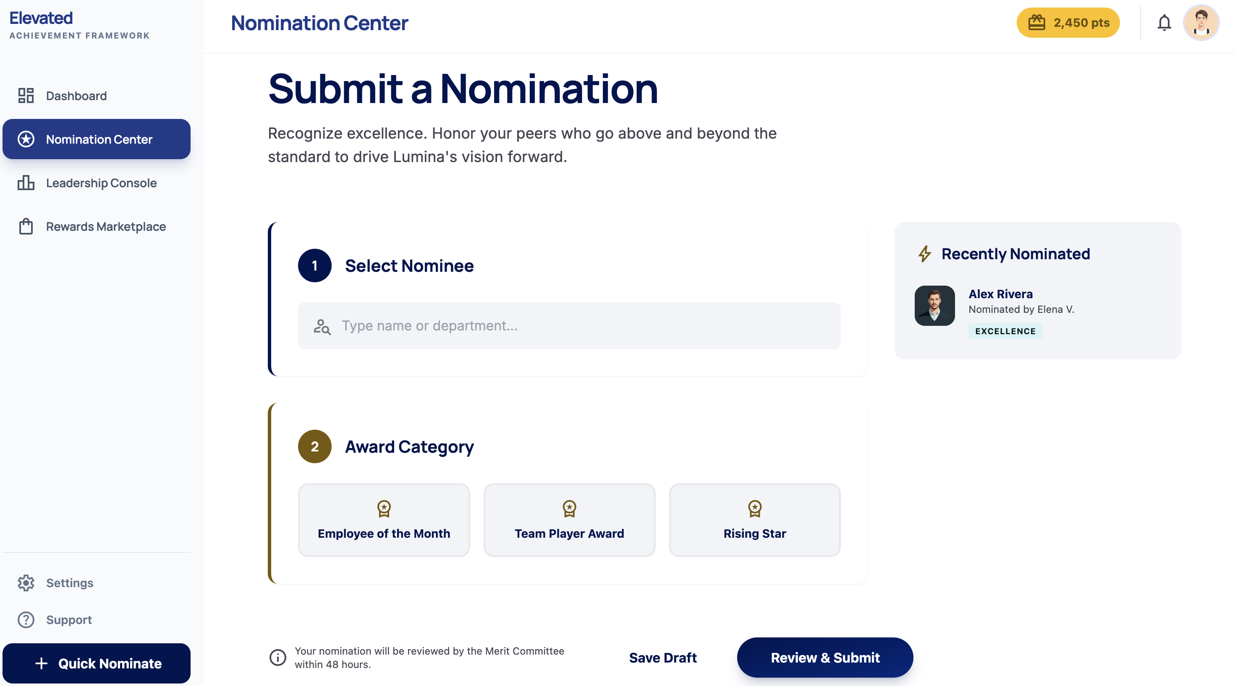Nomination Center: Guided step-by-step form with award category selection (Employee of the Month, Team Player Award, Rising Star) and real-time nomination feedback.

B. Point Allocation & Engagement Tracking
Top-Down Bestowal:
- Leadership and authorized managers can instantly award ad-hoc points from a dedicated "Bestow Points" interface.
- Requires selection of recipient, point amount, and reason/category.
- Bestowed points appear immediately on the employee's dashboard with a recognition notification.
Multi-Stream Accrual: Points are earned through multiple configurable streams:
Stream | Point Value | Trigger
Employee of the Month (Approved) | Configurable by admin | QA queue approval
Rising Star of the Month (Approved) | Configurable by admin | QA queue approval
Team Impact Award (Approved) | Configurable by admin | QA queue approval
TAC Meeting Attendance | Configurable by admin | Admin check-in or attendance import
TAC Meeting Role Completion | Configurable by admin | Role fulfilled confirmation
Newsletter Trivia | Configurable by admin | Correct answer submission
Culture Group Participation | Configurable by admin | Group leader/admin attendance log
Volunteer / Event Help | Configurable by admin | Admin post-event confirmation
Social Media Engagement | Configurable by admin | Screenshot review approval
Birthday Milestone | Configurable by admin | Automated (Paycom DOB sync)
Work Anniversary Milestone | Configurable by admin | Automated (Paycom hire date sync)
Leadership Bestowal | Variable | Manual award by leadership

- All point values are administrator-configurable — no code changes needed to adjust values.
- Milestone points (birthdays, anniversaries) are triggered automatically via scheduled jobs synced with Paycom data.
TAC Meeting RSVP & Role Sign-Ups:
Beyond attendance tracking for points, the platform provides a full TAC meeting management module:
- Event scheduling: Admin creates upcoming TAC meetings with date, time, location, and agenda.
- RSVP workflow: Employees receive a push/email notification and can RSVP (Attending / Not Attending) directly from the app.
- Role sign-ups: Each meeting offers configurable roles — Setup, Check-In, Cleanup, Leadership — that employees can volunteer for on a first-come, first-served basis with capacity limits.
- Automated reminders: Configurable reminders sent 48 hours and 2 hours before the meeting to confirmed attendees.
- Attendance confirmation: Admin marks attendees as present at the meeting; points are awarded automatically upon confirmation.
- Role completion points: Additional bonus points for employees who fulfilled a signed-up role (configurable by admin).
Culture Group Sign-Ups & Participation Tracking:
- Culture group directory: Admin creates and manages culture groups (e.g., Wellness Committee, Diversity Council, Social Events Team) with descriptions and meeting schedules.
- Sign-up portal: Employees browse available culture groups and join with one tap. Capacity limits and approval gates are configurable per group.
- Participation logging: Group leaders or admin log attendance at culture group activities. Points are awarded automatically per participation event.
- Activity feed: Culture group activities appear on the employee dashboard and recognition feed, increasing visibility and encouraging participation.
Volunteer & Event Help Forms:
- Event help request board: Admin posts upcoming events needing volunteers (e.g., fundraisers, holiday parties, community outreach) with descriptions, dates, and role slots.
- Volunteer sign-up: Employees sign up for volunteer slots directly from the app with one-tap enrollment.
- Completion tracking: Admin confirms volunteer participation after the event; points are awarded automatically.
- Volunteer history: Each employee's volunteer record is visible on their profile and contributes to their engagement score.
Social Media Engagement:
- Engagement submission form: Employees submit evidence of social media engagement (e.g., sharing an Arc Mercer post, participating in an awareness campaign) via a simple form with screenshot upload capability.
- Admin review queue: Submitted screenshots are reviewed by admin for approval before points are awarded — preventing fraudulent submissions.
- Point award on approval: Approved social media engagement submissions automatically award configurable points.
- Campaign tracking: Admin can create specific social media campaigns with start/end dates and track participation rates.
Audit Trails:
- Complete, immutable transaction log for every point adjustment:
  - Fields: Timestamp, employee, action type (earned/redeemed/adjusted/voided), point amount, source/reason, performed by.
- Admin reporting dashboard with:
  - Filterable transaction history by employee, program, date range, and type.
  - Export to CSV for external review.
  - Anomaly highlighting (e.g., unusually large bestowals).

C. The Rewards Marketplace
Digital Storefront:
- Clean, visual catalog displaying available rewards with images, point costs, and descriptions.
- Categories: Branded Merchandise, Cafeteria Meals, Digital Gift Cards.
- Real-time point balance displayed prominently during browsing.
- One-tap redemption with confirmation dialog to prevent accidental spending.
- Order history view for employees.
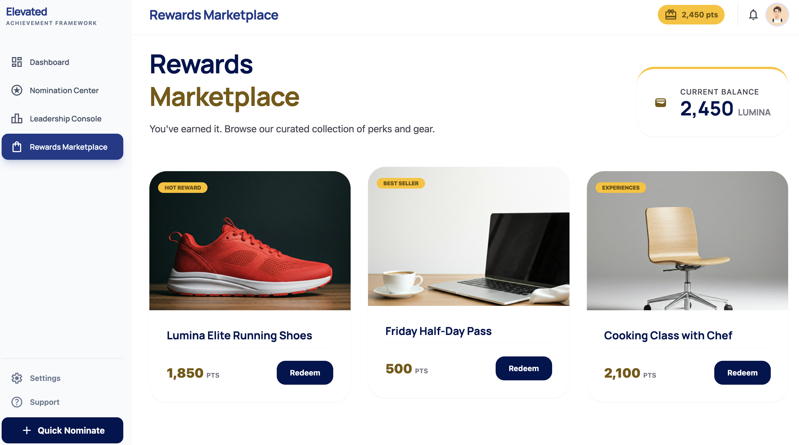Rewards Marketplace: Point balance displayed at a glance, curated product catalog with category badges (Hot Reward, Best Seller, Experiences), and one-tap Redeem buttons.
Fulfillment Tools:
- Admin inventory management dashboard:
  - Add/edit/remove items with images, descriptions, point costs, and stock quantities.
  - Low-stock alerts and out-of-stock auto-hiding.
- Order fulfillment queue:
  - New orders appear in real-time.
  - Status tracking: Pending → Processing → Fulfilled / Shipped.
  - Employee notification on status changes.
- Digital gift card integration:
  - API-based delivery for instant digital gift card fulfillment (e.g., via a vendor such as Tango Card or similar).
  - Automated delivery via email with tracking.
Cafeteria Meal Redemption (Cashier-Facing Screen):
- Dedicated cashier interface: A simplified, tablet-friendly screen for cafeteria staff to process point-based meal redemptions.
- Employee lookup: Cashier searches by name, badge ID, or scans the employee's QR code to pull up the employee's account.
- Balance display & confirmation: The employee's current point balance is displayed prominently. Cashier selects the meal item, confirms the point cost, and the employee approves the deduction.
- Instant point deduction: Points are deducted in real-time upon confirmation. The employee and cashier both see a success confirmation.
- Transaction logging: Every cafeteria redemption is logged in the audit trail with timestamp, employee, cashier, item, and point amount.
- No POS integration required: The cafeteria redemption screen operates independently — the cashier rings up the meal at $0 on their existing POS and processes the point deduction through the platform.
In-Person Store & QR Code Redemption:
- Employee QR code: Each employee has a unique QR code accessible from their profile or home screen in the app.
- Store attendant scanning: At the in-person rewards store, a store attendant scans the employee's QR code using a tablet or phone running the platform's admin interface.
- Browse & select: The attendant selects the physical item being redeemed. The employee's point balance and the item's point cost are displayed for confirmation.
- Point deduction on scan: Points are deducted instantly upon confirmation. The employee receives a push notification confirming the redemption.
- Inventory sync: Physical store inventory levels are updated in real-time, keeping the digital storefront and physical store in sync.

D. User Experience (UX) & Accessibility
Mobile-First Design:
- Progressive Web App (PWA): Installable on any smartphone home screen without app store download — no high-end hardware required.
- Responsive layout: Designed for 320px+ screens, scaling gracefully to tablets and desktops.
- Touch-optimized: Swipe gestures, pull-to-refresh, and haptic-style feedback.
- Low-bandwidth friendly: Lazy-loaded images, compressed assets, and optional offline mode for unreliable connectivity.
Dark Mode / Light Mode:
- Toggle switch: Users can switch between light and dark themes from their profile or via a persistent toggle in the navigation bar.
- Night-shift optimized: Dark mode provides a low-glare interface for staff working overnight shifts at group homes, reducing eye strain in low-light environments.
- System preference detection: The app automatically defaults to the user's device system preference (light or dark) on first load.
- CSS variable theming: Implemented via CSS custom properties — ensuring consistent dark mode across all components with minimal performance overhead.
Dashboards:
Employee Dashboard:
- Points balance (large, centered display).
- Recent point activity feed.
- Nomination status tracker.
- "Quick Nominate" action button.
- Birthday/Anniversary recognition feed.
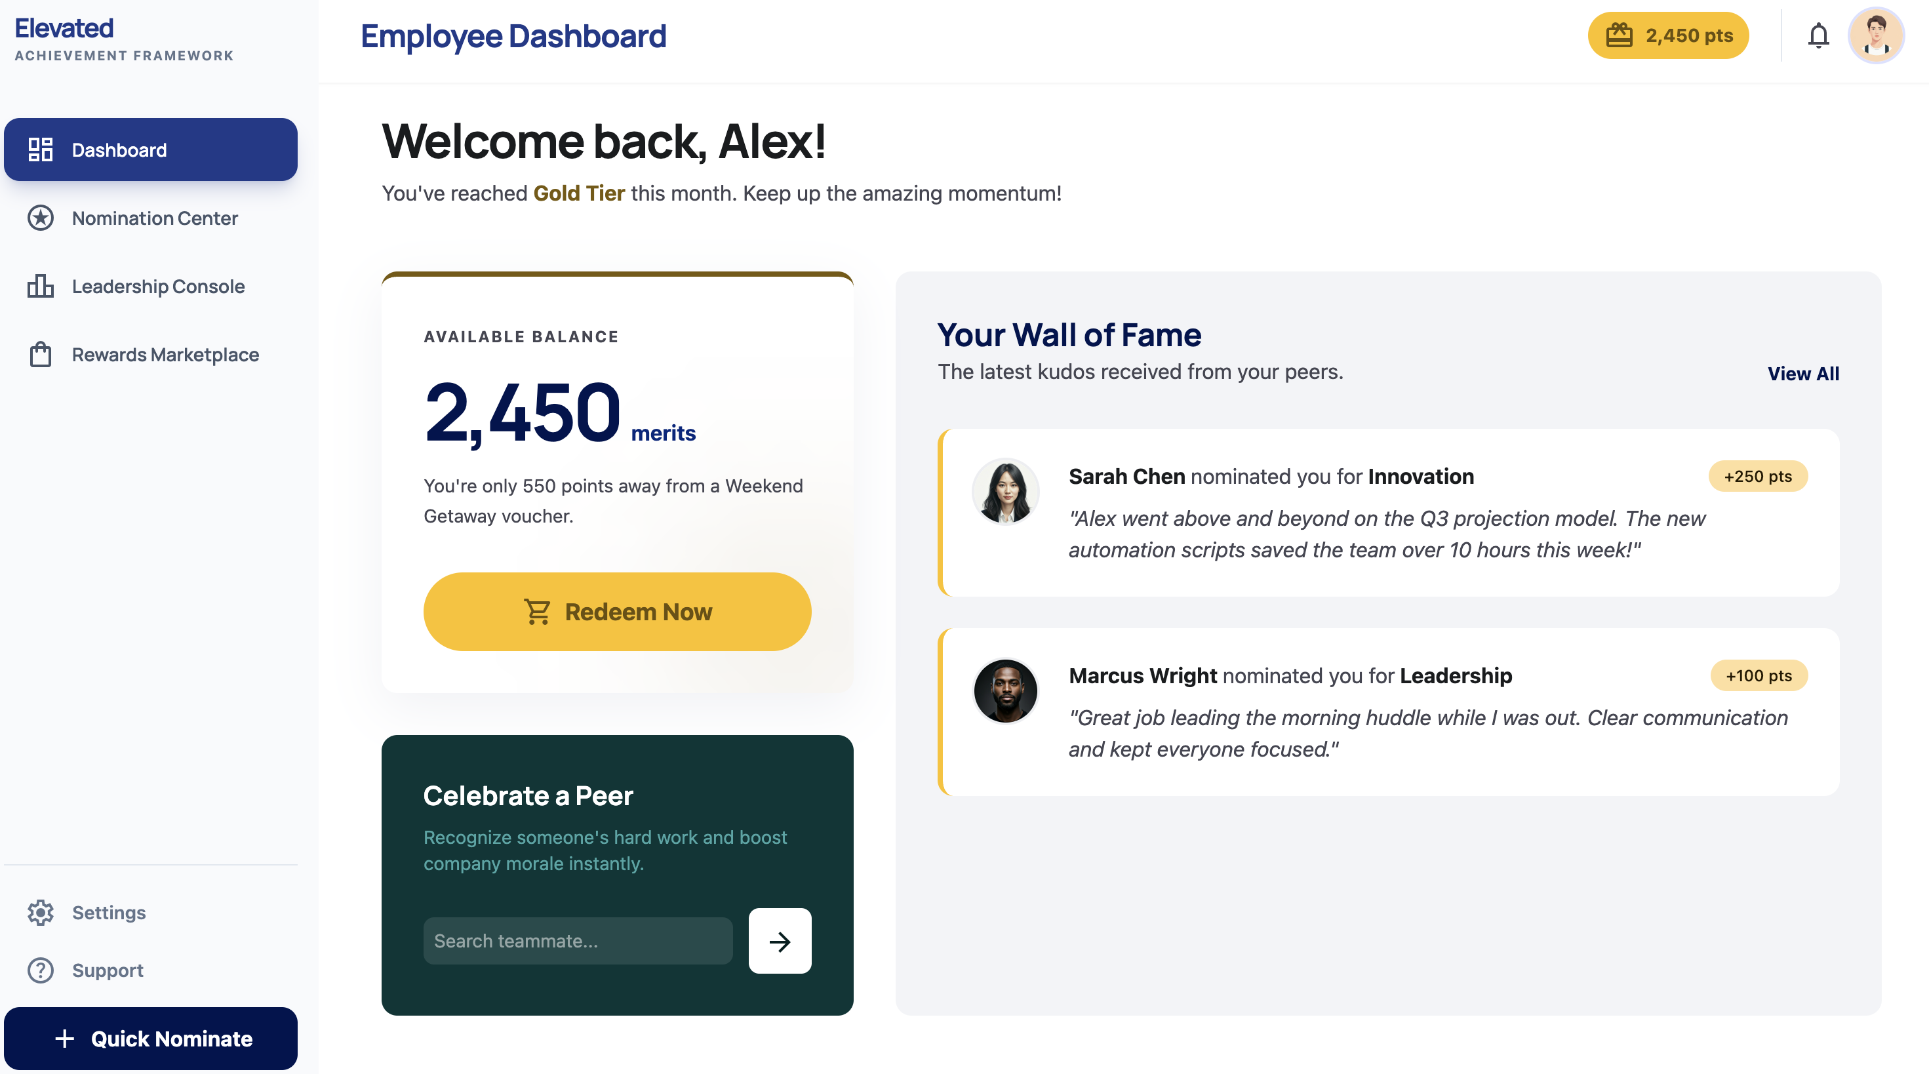Employee Dashboard: Points balance prominently displayed, Wall of Fame showing peer nominations with point awards, and a "Celebrate a Peer" quick-nominate shortcut.
Leadership Dashboard:
- Participation metrics by program (nomination counts, engagement rates).
- Trend charts (weekly/monthly activity).
- QA queue status (pending nominations count).
- Top nominators and nominees leaderboard.
- Point economy overview (points issued vs. redeemed).
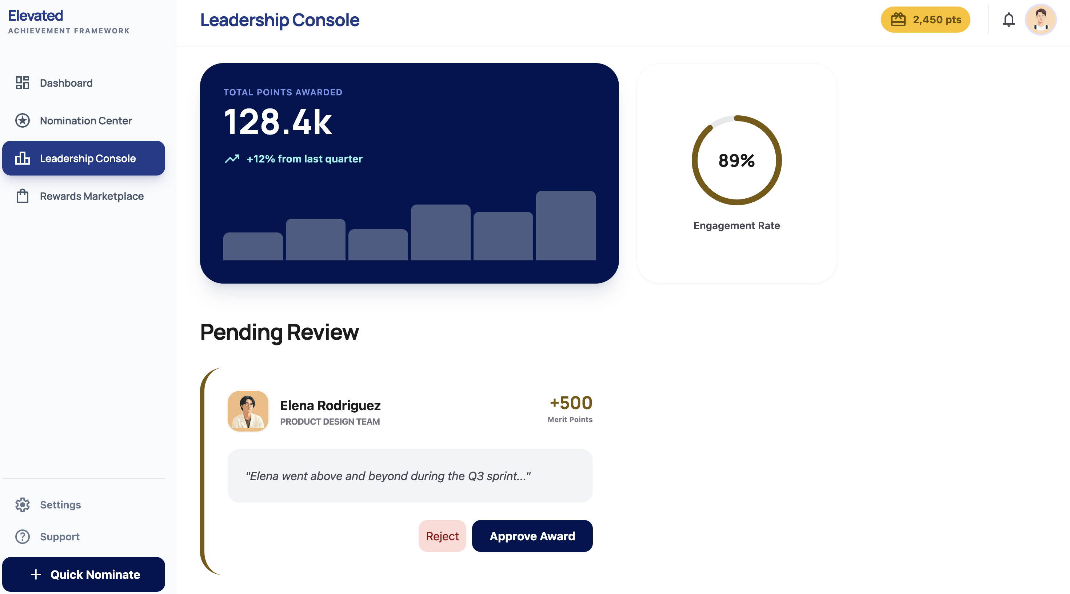Leadership Console: Total points awarded (128.4k, +12% quarter-over-quarter), 89% engagement rate gauge, and Pending Review QA queue with approve/reject actions for nominations.

E. AI Agent Assistant (Optional Add-On)
IoTeye's BrainClaw AI agent framework — already in trials for The Arc Mercer's SpringBoard and Samsara integrations — can be extended to provide a conversational AI assistant directly within the recognition platform.
Natural language capabilities for HR and leadership:
Query | What the Agent Does
"Which program had the most nominations last month?" | Queries the engagement database, returns ranked results by program
"Which employees haven't been recognized in 60+ days?" | Scans all records, flags at-risk staff by department
"Flag any unusual point bestowals this week" | Runs anomaly detection across the full point ledger
"Generate a nominator activity report for Q1" | Assembles and exports a formatted CSV/summary
"What's our overall engagement score this month?" | Calculates real-time KPIs and highlights trends

Technical Implementation:
- A new BrainClaw skill (recognition_agent) with tools bound to the recognition platform's Supabase database via role-scoped queries.
- Accessible from the same BrainBook interface Arc Mercer already uses for SpringBoard and Samsara — one unified AI workspace.
- Will deployed on top of the existing BrainClaw gateway.
- Role-aware: HR directors see org-wide data; program managers see their programs only.
Arc Mercer Advantage: Arc Mercer staff already experiment BrainClaw AI agents to manage transportation operations today. Adding a recognition agent gives leadership a single conversational AI interface for fleet operations, driver compliance, and employee engagement — a capability unique to IoTeye.

5. Integration Strategy

5.1 Paycom Integration (Critical)
We propose a dual-channel integration approach, with SFTP as the primary method and REST API as an optional enhancement:
Primary: SFTP File Transfer
Paycom's standard SFTP export is the most broadly supported integration method and does not require additional API subscription tiers. This is expected to be the primary approach for The Arc Mercer.
- Automated Nightly Sync: Paycom generates a scheduled CSV/XML employee data export, delivered to a secure SFTP endpoint hosted on AWS.
- Python ETL Service: A dedicated Python (FastAPI) service picks up the file, parses, validates, and upserts employee records into Supabase (PostgreSQL).
- Automated User Provisioning:
  - New hires added to the platform automatically after the next sync cycle.
  - Terminated employees automatically deactivated (soft delete — data retained for audit).
  - Program/department assignment changes reflected automatically.
- Data Fields Synced: Employee ID, name, email, program/department assignment, hire date, date of birth, employment status.
- Discrepancy Reports: Any data anomalies (e.g., missing fields, duplicate records) are flagged and sent to HR for review.
- Sync Schedule: Nightly full sync, with the ability to trigger on-demand syncs as needed.
Optional Enhancement: Paycom REST API
If The Arc Mercer's Paycom subscription supports REST API access, we can add near-real-time syncing as an enhancement:
- Event-driven incremental sync (if Paycom webhooks are available).
- Real-time employee lookups for faster onboarding.
- This can be added at any time without disrupting the SFTP-based sync.
Integration Architecture:
Paycom HRIS │ ├── SFTP Export (Primary) ──► AWS S3 ──► Python ETL Service (FastAPI) │ │ └── REST API (Optional) ───────────────────────┤ │ ▼ Supabase (PostgreSQL) Employee Records Table │ ▼ React Front End (Live Data)
Error Handling & Monitoring:
- Retry logic with exponential backoff for API failures.
- Admin notifications for sync errors or data discrepancies.
- Monthly sync health reports.

5.2 Single Sign-On (SSO) & Frontline Authentication
We recognize that The Arc Mercer's workforce includes a significant number of frontline direct-support professionals who may not have organizational email addresses. Our authentication strategy provides three login paths to ensure every employee can access the platform:
Path 1: Badge ID + PIN (Frontline Staff)
For frontline DSPs and staff without Arc Mercer email addresses:
- Paycom Badge ID login: Employees sign in using their Paycom employee badge ID — the identifier they already carry and use daily.
- Self-set PIN: On first login (provisioned automatically via Paycom sync), the employee sets a 4-6 digit PIN as their credential. No email address required.
- Simple login flow: Enter badge ID → enter PIN → authenticated. Designed for speed and simplicity on a smartphone.
- PIN reset: Admin can trigger a PIN reset for any employee. The employee sets a new PIN on next login.
- Security: PINs are hashed and salted in the database. Failed login attempts trigger a lockout after 5 tries (configurable) with admin notification.
Path 2: Google Workspace SSO (Admin & Management Staff)
- Supabase Auth natively supports SAML 2.0, OAuth 2.0, and OIDC — enabling flexible identity provider configuration without code changes.
- Initial Deployment: Google Workspace SSO — We will configure SSO with The Arc Mercer's current Google Workspace identity provider. Admin and management staff sign in with their existing Google organizational accounts.
- Future Migration Path: Microsoft Entra ID (Azure AD) — Supabase Auth supports multiple identity providers simultaneously. When The Arc Mercer migrates to Microsoft, we can add Microsoft Entra ID as an SSO provider with zero downtime — both providers can run in parallel during the transition period.
- Employee experience: Click "Sign In with Google" → redirect to familiar Google (or future Microsoft) login → automatically authenticated and returned to the platform.
Path 3: Email/Password Fallback
- Fallback: Email/password login for users who prefer traditional credentials or have email addresses but are not on the SSO identity provider (e.g., part-time or seasonal staff), with secure password policies enforced.

6. Accessibility Statement
Our commitment to accessibility is central to this project, given The Arc Mercer's diverse workforce:

Design Philosophy
We design for the least technically experienced user first. Every interface decision is validated against the question: "Could a person who only uses their phone for calls and texts successfully complete this action?"

Specific Accommodations
Challenge | Our Solution
Low technical literacy | Icon-based navigation, step-by-step guided flows, no jargon
Small screen / older phones | Mobile-first PWA, works on any modern browser, no app download required
Low vision / contrast needs | WCAG AAA contrast ratios, large fonts (min 16px body text), resizable text
Motor difficulties | Large touch targets (48x48px minimum), generous spacing between actions
Cognitive load | Progressive disclosure, one primary action per screen, clear success/error messaging
Language diversity | Simple language (6th grade level), icon-first design reduces language dependency

Ongoing Accessibility
- User testing with frontline staff during each phase.
- Accessibility audit before each phase launch.
- Feedback mechanism built into the app for reporting usability issues.

7. Phased Implementation Plan & Timeline

Phase One: Foundation (Weeks 1–12)
Centralized nominations, selection committee voting, Paycom sync, and manual point support
Week | Milestone
1–2 | Kickoff & Discovery  — Requirements workshops with stakeholders, Paycom SFTP access setup, environment provisioning
3–5 | Core Infrastructure  — AWS deployment pipeline, Supabase schema design, authentication configuration (Badge ID + PIN, Google SSO), Paycom integration development
6–8 | Nomination Engine & Voting  — Submission portal, QA queue with revise-and-resubmit workflow, selection committee ranked-choice voting module, program hierarchy, nomination business rules
9–10 | Point System (Manual)  — Admin point bestowal, point balance views, audit trail, leadership dashboard
11 | User Acceptance Testing (UAT)  — Testing with selected staff across programs, accessibility audit
12 | Phase One Launch  — Production deployment, staff onboarding, admin training

Phase One Deliverables:
- Nomination submission portal (Employee of the Month, Rising Star, Team Impact)
- QA queue with approve/return/decline workflow and formalized revise-and-resubmit loop
- Selection committee ranked-choice voting module with drag-and-drop ranking, private ballots, and automated tally
- Paycom user sync (automated provisioning)
- Badge ID + PIN login for frontline staff
- Google Workspace SSO for admin/management staff
- Manual point bestowal by leadership
- Basic point balance display
- Admin audit trail

Phase Two: Engagement (Weeks 13–24)
Individual dashboards, automated activity tracking, and community engagement modules
Week | Milestone
13–15 | Employee Dashboards  — Personalized point history, nomination tracker, activity feed, dark mode toggle
16–18 | Leadership Dashboards  — Participation metrics, trend charts, program comparisons, leaderboards
19–21 | Automated Tracking & Engagement Modules  — TAC meeting RSVP/role sign-ups/attendance, newsletter trivia, birthday/anniversary automation, culture group sign-ups, volunteer/event forms, social media engagement with screenshot upload
22–23 | UAT & Refinement  — User testing, performance optimization
24 | Phase Two Launch  — Feature rollout, updated training materials

Phase Two Deliverables:
- Full employee dashboards with point history and progress
- Leadership analytics dashboards with trends
- Dark mode / light mode toggle for night-shift staff
- Automated birthday and anniversary point awards
- TAC meeting RSVP, role sign-ups (setup, check-in, cleanup, leadership), attendance tracking with automated reminders
- Culture group sign-ups and participation tracking
- Volunteer / event help forms with sign-up and completion tracking
- Social media engagement form with screenshot upload and admin review
- Newsletter trivia integration
- Push/email notifications

Phase Three: Marketplace (Weeks 25–36)
Full Store activation, in-person redemption, and fulfillment workflows
Week | Milestone
25–27 | Storefront Development  — Product catalog, category browsing, point-based checkout
28–30 | Fulfillment & In-Person Redemption  — Order management, status tracking, admin inventory tools, cafeteria cashier-facing redemption screen, in-person store QR code scanning
31–33 | Gift Card Integration  — Vendor API integration, automated digital delivery
34–35 | UAT & Load Testing  — End-to-end testing, security audit
36 | Phase Three Launch & Full Platform Go-Live

Phase Three Deliverables:
- Digital rewards storefront
- Physical merchandise ordering and fulfillment tracking
- Digital gift card instant delivery
- Cafeteria meal redemption with cashier-facing lookup screen (search by name, badge ID, or QR scan; confirm balance; deduct points)
- In-person rewards store QR code scanning (employee QR code on profile, attendant scans to redeem)
- Inventory management tools with real-time sync between digital and physical store
- Complete platform with all features active

Overall Timeline Summary
Month 1–3: ████████████████ Phase One (Foundation) Month 4–6: ░░░░░░░░░░░░████████████████ Phase Two (Engagement) Month 7–9: ░░░░░░░░░░░░░░░░░░░░░░░░████████████████ Phase Three (Marketplace)
Total Duration: ~36 weeks (9 months) from kickoff to full launch.

8. Cost Proposal
We offer three pricing options to accommodate different budget and ownership preferences:

Option A: Source-Code Ownership (Custom Build)
Under this option, The Arc Mercer owns the source code and all intellectual property. IoTeye delivers the platform, and The Arc Mercer retains full control to modify, extend, or migrate the system independently in the future.

8.1 Implementation Fees (One-Time)
Phase | Description | Est. Hours | Cost
Phase One | Nominations, Selection Committee Voting, Paycom Sync, Badge ID + PIN Auth, SSO, Manual Points, Core Infrastructure | ~480 hrs | $45,000
Phase Two | Dashboards, Engagement Modules (TAC RSVP, Culture Groups, Volunteer, Social Media), Dark Mode, Notifications | ~310 hrs | $35,000
Phase Three | Rewards Marketplace, Cafeteria Redemption, In-Person QR Store, Gift Card Integration, Fulfillment | ~280 hrs | $30,000
Total Implementation |  | ~1,070 hrs | $110,000

Includes: discovery, design, development, testing, deployment, training, and documentation.
Detailed Effort Breakdown:
Phase One — $45,000 (~480 hours, Weeks 1–12)
Task | Hours
Discovery & requirements workshops | ~35
AWS infrastructure setup (ECS, CloudFront, CI/CD pipeline) | ~35
Supabase schema design, RLS policies, auth configuration (Badge ID + PIN, Google SSO) | ~50
Paycom integration service (SFTP + optional API, error handling, monitoring) | ~75
Nomination engine + selection committee voting (submission portal, ranked-choice drag-and-drop, ballots, tally, business rules) | ~90
QA queue (admin dashboard, approve/return/decline, revise-and-resubmit workflow) | ~65
Manual point bestowal + audit trail | ~35
UI/UX design (mobile-first, WCAG AAA, icon-driven, accessibility) | ~55
UAT, accessibility audit, deployment, staff training | ~40

Phase Two — $35,000 (~310 hours, Weeks 13–24)
Task | Hours
Employee dashboards (point history, nomination tracker, activity feed) | ~70
Leadership dashboards (analytics, trend charts, program comparisons) | ~65
Engagement modules (TAC RSVP/role sign-ups, culture groups, volunteer/event forms, social media engagement with screenshot upload, birthday/anniversary automation, newsletter trivia) | ~100
Dark mode / light mode (CSS variable theming, system preference detection) | ~10
Notification system (push + email) | ~35
UAT & refinement | ~30

Phase Three — $30,000 (~280 hours, Weeks 25–36)
Task | Hours
Rewards storefront (catalog, browsing, point-based checkout) | ~70
Fulfillment system + cafeteria redemption + in-person QR store (order queue, status tracking, inventory management, cashier-facing screen, QR code scanning) | ~95
Gift card vendor API integration + automated delivery | ~55
Load testing, security audit, final deployment | ~40
Documentation & admin training | ~20

**Blended rate: ~103/hr∗∗across 1,070hours—wellbelowthe103/hr** across ~1,070 hours — well below the 103/hr∗∗across 1,070hours—wellbelowthe150–$250/hr industry standard for custom SaaS development.

8.2 Annual Licensing & Hosting (Recurring)
Item | Annual Cost
AWS Infrastructure (hosting, CDN, storage, monitoring) | $6,000
Supabase Pro Plan (database, auth, real-time) | $3,000
SSL Certificates & Domain Management | $200
Maintenance & Support (bug fixes, security patches, minor updates) | $12,000
Total Annual Cost | $21,200/year

Option A Cost Summary
Category | Year 1 | Year 2+
Implementation | $110,000 | —
Annual Licensing & Hosting | $21,200 | $21,200
Total | $131,200 | $21,200/year

What you own: Full source code, database schema, deployment infrastructure, and all IP. The Arc Mercer can self-host, bring in other developers, or modify the platform without restriction after delivery.

Option B: IoTeye-Hosted SaaS (No Implementation Fee)
Under this option, IoTeye Inc. retains ownership of the platform and source code and operates it as a managed SaaS service. The Arc Mercer pays no upfront implementation fee — instead, IoTeye recoups development costs through a monthly subscription. IoTeye may offer the platform to other organizations in the future.

Pricing
Item | Cost | Annual Cost
Platform Subscription (all features, all phases) | $2,500/month | $30,000/year
Hosting, maintenance, security updates, and support | $500/month | $6,000/year
Total | $3,000/month | $36,000/year

- No implementation fee. IoTeye absorbs the full development cost.
- Minimum commitment: 3-year initial term, renewing annually thereafter.
- Includes: All three phases delivered on the same timeline (36 weeks), plus ongoing hosting, maintenance, support, and security updates.

Option B Cost Summary
Category | Annual Cost
Implementation Fee | $0
Platform Subscription (includes hosting, maintenance, support) | $36,000/year
Total | $36,000/year

What you get: Fully managed platform with no upfront cost, ongoing updates, and support. IoTeye handles all infrastructure, security, and maintenance.
What IoTeye retains: Source code ownership and the right to offer the platform (excluding The Arc Mercer's data) to other organizations.

Option C: Shared Ownership (Hybrid)
Under this option, The Arc Mercer pays half of the implementation fee and receives shared ownership (50/50) of the recognition platform source code — the new application built specifically for this project. The Arc Mercer retains sole ownership of the database schema, data, and deployment configuration. IoTeye's existing products (BrainBook, SpringBoard, Guardian, and the BrainClaw AI agent gateway) are excluded from the ownership transfer and remain IoTeye intellectual property. Specific terms governing shared code ownership (usage rights, licensing, distribution) will be documented in a separate legal agreement between the parties.
IoTeye commits to hosting and maintaining the platform as a managed service for a minimum of 3 years, identical to Option B.

Implementation Fee (One-Time)
Item | Cost
50% of full implementation ($110,000) | $55,000

Covers the same scope as Option A (all three phases, 1,070 hours, 36-week delivery). The reduced fee reflects shared investment — IoTeye absorbs half the development cost in exchange for retaining ownership of its existing product ecosystem.

Annual Platform Fee (Recurring)
Item | Annual Cost
Platform Hosting, Maintenance, Security Updates, and Support | $36,000/year

- Same managed service as Option B — IoTeye handles all infrastructure, monitoring, security patches, and support.
- Minimum commitment: 3-year initial term, renewing annually thereafter.

Code Ownership Scope
Component | Ownership
Recognition platform (nominations, points, rewards, dashboards, engagement modules) | Shared (50/50)
Database schema & data | The Arc Mercer
Deployment configuration (AWS IaC) | The Arc Mercer
BrainBook (AI platform) | IoTeye Inc.
SpringBoard (route management) | IoTeye Inc.
Guardian (notification & authentication system) | IoTeye Inc.
BrainClaw AI gateway & agents | IoTeye Inc.

Option C Cost Summary
Category | Year 1 | Year 2+
Implementation (50%) | $55,000 | —
Annual Platform Fee | $36,000 | $36,000/year
Total | $91,000 | $36,000/year

What you co-own: 50/50 shared ownership of the recognition platform source code (nomination engine, point system, rewards marketplace, dashboards, engagement modules) — specific terms (usage rights, licensing, distribution) deferred to legal agreement. Sole ownership of database schema, data, and deployment configuration. IoTeye hosts and maintains the platform for a minimum of 3 years; after the initial term, The Arc Mercer can hire other developers to modify or extend the recognition platform independently.
What IoTeye retains: BrainBook, SpringBoard, Guardian, and BrainClaw gateway — these existing products remain IoTeye intellectual property and are not included in the ownership transfer.
What's deferred to legal agreement: Platform reuse rights, exclusivity terms, and any licensing arrangements between the parties will be documented in a separate agreement.

Option A vs. Option B vs. Option C Comparison
Factor | Option A (Source Ownership) | Option B (IoTeye SaaS) | Option C (Shared Ownership)
Upfront Cost | $110,000 | $0 | $55,000
Annual Cost | $21,200/year | $36,000/year | $36,000/year
3-Year Total Cost | $173,600 | $108,000 | $163,000
5-Year Total Cost | $216,000 | $180,000 | $235,000
Source Code Ownership | ✅ The Arc Mercer owns all code | ❌ IoTeye retains ownership | ⚠️ 50/50 recognition platform; DB & infra: Arc Mercer sole ownership
Vendor Independence | ✅ Can self-host or hire other devs | ❌ Dependent on IoTeye | ⚠️ Shared recognition code; IoTeye products require IoTeye
Customization Freedom | ✅ Unlimited modifications | ⚠️ Customizations by request | ⚠️ Recognition platform modifiable per legal terms; IoTeye products by request
Platform Updates | ⚠️ Paid separately | ✅ Included in subscription | ✅ Included in annual fee
Best For | Long-term control & independence | Lower upfront risk & managed service | Balanced cost & flexibility

8.3 Gift Card Transaction Fees (All Options)
Method | Fee Structure
Digital Gift Cards (via vendor API) | Vendor markup of 3–5% on face value (passed through at cost, no additional markup)
Physical Merchandise | No transaction fee; inventory purchased at wholesale by The Arc Mercer
Cafeteria Meals | No transaction fee; internal redemption tracking only

8.4 Optional Add-Ons (All Options)
The following add-ons are available across all pricing options. AI-assisted enhancements — tasks that BrainClaw AI agents can perform autonomously or with minimal human oversight — are included at no additional cost beyond the AI LLM usage fee (billed at cost, pass-through only). Major system redesign or feature rebuilds that require significant engineering effort are available upon request and will be scoped collaboratively.

AI-Assisted Add-Ons (LLM Usage Fee Only)
Add-On | Cost
Recognition AI Agent (BrainClaw skill + BrainBook integration) | $0 — AI LLM usage fee only (pass-through)
Additional Paycom integration fields | $0 — AI LLM usage fee only (pass-through)
Additional training sessions (per session) | $0 — AI LLM usage fee only (pass-through)

9. Appendices

Appendix A: Technology Stack Detail
Layer | Technology | Version/Service
Front End | React | 18+
Language | TypeScript | 5+
UI Framework | Tailwind CSS + Headless UI | Latest
Backend/Database | Supabase (PostgreSQL) | Managed Cloud
Integration Services | Python (FastAPI) | 3.11+
Cloud Platform | AWS | ECS Fargate, CloudFront, S3, Secrets Manager, CloudWatch
CI/CD | GitHub Actions | Automated testing and deployment
Monitoring | AWS CloudWatch + Sentry | Error tracking and performance monitoring

Appendix B: Data Security Summary
- AES-256 encryption at rest
- TLS 1.3 encryption in transit
- Row Level Security (RLS) at the database level
- SOC 2 Type II eligible AWS infrastructure
- Regular security patching and dependency updates
- Principle of least privilege access controls
- Immutable audit logs

Appendix C: Support & Maintenance
Included in Annual Support:
- Bug fixes and security patches (48-hour SLA for critical issues)
- Supabase and AWS infrastructure monitoring
- Quarterly system health reports
- Email and phone support during business hours (M–F, 9 AM – 5 PM ET)
Response Time SLAs:
Severity | Description | Response Time | Resolution Target
Critical | Platform down / data loss | 2 hours | 8 hours
High | Major feature unavailable | 4 hours | 24 hours
Medium | Non-critical bug / UI issue | 1 business day | 5 business days
Low | Enhancement request / question | 2 business days | Next scheduled release

Appendix D: Competitive Feature Matrix & Revision Log
This appendix provides a comprehensive feature-by-feature comparison of the three proposals submitted for The Arc Mercer's Employee Engagement & Recognition Platform RFP, followed by a detailed log of all features added to this proposal during the competitive revision process.
Legend: ✅ = Included | 🆕 = Newly added in this revision | — = Not included | ⚠️ = Partial

Part 1: Feature Comparison Matrix
Nomination & Recognition
# | Feature | IoTeye | Proposal 1 | Proposal 2 | Phase | Notes
1 | Peer-to-Peer Nominations | ✅ | ✅ | ✅ | 1 | Core RFP requirement; all vendors include
2 | Manager / Supervisor Nominations | ✅ | ✅ | ✅ | 1 | Role-based nomination paths
3 | Category-Based Awards (quarterly, annual, spot) | ✅ | ✅ | ✅ | 1 | IoTeye includes customizable categories with admin controls
4 | Nomination Templates & Guided Forms | ✅ | ⚠️ Partial | ✅ | 1 | IoTeye offers structured templates; P1 has basic form fields
5 | Batch QA Queue Operations | ✅ | — | — | 1 | IoTeye-exclusive for high-volume nomination periods
6 | Formalized Revise-and-Resubmit Loop | 🆕 | ✅ | — | 1 | Status tracking through full revision cycle; previously implicit

Selection & Voting
# | Feature | IoTeye | Proposal 1 | Proposal 2 | Phase | Notes
7 | Selection Committee Voting | 🆕 | ✅ | ✅ | 1 | Private ballots with configurable committee membership
8 | Ranked-Choice Drag-and-Drop Voting | 🆕 | ⚠️ Partial | ✅ | 1 | P2 identified Arc Mercer uses ranked-choice today
9 | Automated Vote Tally & Winner Declaration | 🆕 | ✅ | ✅ | 1 | Ties resolved by committee chair; results audit-logged

Authentication & Access Control
# | Feature | IoTeye | Proposal 1 | Proposal 2 | Phase | Notes
10 | SSO (Google Workspace / Microsoft Entra ID) | ✅ | — | — | 1 | IoTeye includes multi-IDP with zero-downtime migration path
11 | Email / Password Fallback | ✅ | — | — | 1 | Standard credential-based login
12 | Badge ID + PIN Login (frontline staff) | 🆕 | — | ✅ | 1 | Critical for DSPs lacking company email addresses
13 | Magic Link Authentication | — | ✅ | — | — | P1 approach; IoTeye addresses gap via badge ID + PIN instead
14 | Multi-IDP Migration Path (Google → Microsoft) | ✅ | — | — | 1 | Both providers run in parallel during transition

Engagement & Participation Modules
# | Feature | IoTeye | Proposal 1 | Proposal 2 | Phase | Notes
15 | TAC Meeting Attendance Logging & Points | ✅ | ✅ | ⚠️ Partial | 2 | IoTeye: admin check-in or CSV import with auto-points
16 | TAC RSVP & Role Sign-Ups | 🆕 | ✅ | — | 2 | RSVP workflow with role selection (setup, check-in, cleanup, leadership)
17 | Culture Group Sign-Ups & Participation | 🆕 | ✅ | — | 2 | Self-service sign-up with attendance tracking and auto-points
18 | Volunteer / Event Help Forms | 🆕 | ✅ | — | 2 | Form builder for event volunteering with approval workflow
19 | Social Media Engagement (Screenshot Upload) | 🆕 | ✅ | — | 2 | Upload proof of social media engagement for point awards
20 | Anniversary & Milestone Automation | ✅ | ✅ | ✅ | 2 | Automated recognition for work anniversaries and tenure milestones

Rewards Marketplace & Redemption
# | Feature | IoTeye | Proposal 1 | Proposal 2 | Phase | Notes
21 | Digital Storefront (browse, filter, redeem) | ✅ | ✅ | ✅ | 3 | Points-based online catalog
22 | Gift Card Integration (Amazon Business) | ✅ | ⚠️ Partial | ✅ | 3 | IoTeye: Amazon Business API; P1 mentions gift cards generically
23 | Cafeteria Cashier Redemption Screen | 🆕 | ✅ | — | 3 | Dedicated cashier-facing lookup, balance check, and point deduction
24 | In-Person Store QR Code Scanning | 🆕 | — | ✅ | 3 | QR code scanning for physical reward store redemption
25 | Swag / Merchandise Fulfillment | ✅ | ✅ | ⚠️ Partial | 3 | Admin order management with shipping tracking

Analytics, AI & Reporting
# | Feature | IoTeye | Proposal 1 | Proposal 2 | Phase | Notes
26 | BrainClaw AI Agent (NLP analytics) | ✅ | — | — | 2 | IoTeye-exclusive; 94+ tools already in production at Arc Mercer
27 | Leadership Dashboards & Reports | ✅ | ✅ | ✅ | 2 | Department-level participation, point balance, and trend analytics
28 | Anomaly Detection & Flagging | ✅ | — | — | 2 | Automatic flagging of unusual point bestowals
29 | Immutable Audit Trail & CSV Export | ✅ | ⚠️ Partial | ⚠️ Partial | 1 | Full field detail: timestamp, actor, action, amount, source

Technical & Infrastructure
# | Feature | IoTeye | Proposal 1 | Proposal 2 | Phase | Notes
30 | Dark Mode / Light Mode Toggle | 🆕 | — | ✅ | 2 | Critical for night-shift staff at group homes
31 | Offline Capability | ✅ | — | — | 1 | Lazy-loaded images, compressed assets for low-connectivity
32 | Push Notifications (Mobile + Email + SMS) | ✅ | ⚠️ Partial | — | 2 | IoTeye: Twilio SMS + Expo push + email; P1: email + in-app only
33 | WCAG AAA Accessibility (7:1 contrast) | ✅ | — | ⚠️ Partial | All | IoTeye targets AAA; P2 mentions "high-contrast" generically
34 | Screen Reader & Keyboard Navigation | ✅ | — | — | All | Semantic HTML, ARIA labels, NVDA/VoiceOver tested
35 | Severity-Based SLA Tiers | ✅ | — | — | Post | Critical 2hr / High 4hr / Medium 1 day / Low 2 days
36 | AWS HIPAA-Eligible Infrastructure (99.9% uptime) | ✅ | — | — | All | WAF, VPC isolation, Secrets Manager, CloudWatch
37 | Source Code Ownership Option | ✅ | ⚠️ Partial | — | — | Option A: full IP and source code transfer to Arc Mercer

Summary: IoTeye covers 36 of 37 features (including 10 newly added). Proposal 1 covers 21. Proposal 2 covers 18.

Part 2: Revision Change Log
The following 10 features were added to this proposal after competitive analysis. All features are absorbed into the existing **110,000budget∗∗(1,070hours)throughredistributionofphase−levelestimates.Phasecostsremainunchangedat110,000 budget** (1,070 hours) through redistribution of phase-level estimates. Phase costs remain unchanged at 110,000budget∗∗(1,070hours)throughredistributionofphase−levelestimates.Phasecostsremainunchangedat45,000 / 35,000/35,000 / 35,000/30,000.
# | Feature Added | Section(s) Modified | Phase | Competitor Source | Before → After
1 | Selection Committee Voting (ranked-choice drag-and-drop) | 4A, 7, 9 | Phase 1 | P1, P2 | QA queue supported approve/return/decline only → Full committee voting with ranked-choice drag-and-drop ballots, configurable committee membership, and automated tally with tie-breaking
2 | Formalized Revise-and-Resubmit Loop | 4A, 7 | Phase 1 | P1 | Implicit "Return for Edits" with comment field → Explicit revision workflow with status tracking (Submitted → Under Review → Revisions Requested → Revised → Approved/Declined), revision counter, and full history
3 | Badge ID + PIN Authentication | 5.2, 7, 9 | Phase 1 | P2 | SSO + email/password only → Three login paths: (1) Paycom badge ID + self-set PIN, (2) Google/Microsoft SSO, (3) email/password. Addresses frontline DSPs lacking company email
4 | TAC RSVP & Role Sign-Ups | 4B, 7 | Phase 2 | P1 | TAC attendance logging only → Full RSVP workflow with role selection (setup, check-in, cleanup, leadership), automated reminders, and role-based point bonuses
5 | Culture Group Sign-Ups & Participation | 4B, 7 | Phase 2 | P1 | Not addressed → Self-service group directory, sign-up forms, attendance tracking, and automated participation points
6 | Volunteer / Event Help Forms | 4B, 7 | Phase 2 | P1 | Not addressed → Configurable volunteer sign-up forms with admin approval workflow, shift management, and participation point awards
7 | Social Media Engagement (screenshot upload) | 4B, 7 | Phase 2 | P1 | Not addressed → Screenshot upload form for social media engagement proof, admin review queue, and point awards upon approval
8 | Cafeteria Cashier Redemption Screen | 4C, 7 | Phase 3 | P1 | "Cafeteria meals" listed as reward category with internal tracking → Dedicated cashier-facing interface: employee lookup (name/badge), real-time point balance display, meal item selection, confirmation prompt, and automatic point deduction
9 | In-Person Store QR Code Scanning | 4C, 7, 9 | Phase 3 | P2 | Digital storefront only → QR code generation per reward item, staff scan via mobile app camera, balance verification, and real-time deduction for physical in-person store
10 | Dark Mode / Light Mode Toggle | 4D, 7 | Phase 2 | P2 | Not addressed → System-preference-aware dark/light mode toggle, persisted per user, with WCAG AAA contrast maintained in both themes. Supports night-shift staff at group homes

IoTeye Inc. appreciates the opportunity to submit this proposal and looks forward to partnering with The Arc Mercer to build a recognition platform that celebrates and retains your dedicated workforce. We are available for a follow-up presentation or demo at your convenience.
Contact:IoTeye Inc. Basking Ridge, New Jersey, USA mingjye.sheng@ioteyeinc.com https://www.ioteyeinc.com

